Name: _____________________ Class:__________ Date:__________
Instructions: Write answers in the right-hand column. Score: ___________ / 55 marks
Section A— Multiple choice (10 marks)

 | Sally ran an experiment and took a series of temperature measurements with a thermometer. Which of the following best describes the type of data that she collected?  A first-hand data  B second-hand data  C qualitative data  D internet data | A | 1
 | Mistakes:  A are the same as errors.  B can be avoided if you take care.  C always happen, regardless of how careful you are.  D never happen. | B | 1
 | To tare an electronic scale is to:  A break it.  B set it to zero, when something is already on it.  C measure the mass of something on it.  D read the scale correctly. | B | 1
 | Victor wrote in his prac report that the temperature of the water was 27 ± 1°C. This means that the temperature of the water was:  A 27°C exactly.  B between 1°C and 27°C.  C between 27°C and 28°C.  D between 26°C and 28°C. | d | 1
 | Which of the following website is Australian?  A www.traveltoaustralia.org.uk  B www.australian_visas.gov  C www.australian_tourism.gov.au  D www.australian_universities.edu.ae | C | 1
 | Four students wrote the same book in their resource list in four very different ways. Which is the correct way?  A The book was called Volcanoes. It was written by George Jones in 2008 and was published in Melbourne by Volcanic Press.  B Jones, George, Volcanoes, 2008, Volcanic Press, Melbourne.  C Volcanoes, by George Jones, 2008, from Volcanic Press, Melbourne.  D Title: Volcanoes, Author: George Jones, Publisher: Volcanic Press, Year: 2008. | B | 1
 | Four students wrote about how they found the length of the oval. Which of the following is the best way of writing it for a prac report?  A We measured the length of the oval.  B The length of the oval was measured.  C We used a trundle wheel to measure the length of the oval.  D The oval was 210 m long. | C | 1
 | Amy ran an experiment in which her aim was: ‘To find out which flowed faster, water or honey’. Which of the following is the best conclusion for her experiment?  A Honey is really tasty.  B Honey is sweet and brown in colour.  C The experiment was fun and I learnt a lot.  D Water flowed much faster than honey. | D | 1
 | Which of the following represents the largest volume of water?  A 1 mL  B 1 L  C 1 ML  D 1 GL | d | 1
 | Extrapolation is when you:  A plot a line graph.  B logically extend a line graph.  C explore the South pole.  D change a liquid into a gas. | b | 1

Section B— Short answer (35 marks)

 | a State an observation about your school that is qualitative.  b State an observation about your school that is quantitative. | a Any observation that does not include numbers or measurements can be given, for example, the colour of its brick, whether students are in uniform or not, its name, its suburb/town.  b Any observation that includes numbers and measurements can be given, for example, the number of students or teachers, the number of rooms, the length of the school oval. | 2
 | Joe used a stopwatch to measure the time taken for a stone to drop to the bottom of a cliff.  a Explain how human reaction times will bring errors into his measurements.  b Propose ways in which he might reduce these errors. | a The best human reaction time is about 0.110 seconds. Joe will have reaction time errors when he first starts the stopwatch (when he first drops the stone) and when he stops the stopwatch (when the stone hits the ground). This will give him a total error of at least 0.220 s.  b Multiple measurements and averaging their results will reduce these errors. Better still, he should have a number of different people timing the drop also. | 4
 | Hot objects should always be cooled before measuring their mass using an electronic balance. Propose reasons why. | Within an electronic balance will be metal parts that will expand when heated. This may cause the scale to give an incorrect mass. | 2
- ` | Websites with the domain ‘.edu’ can normally be trusted.  a Explain why.  b Although normally trustworthy, they still need to be treated with care. Explain why. | a The domain ‘.edu’ indicates that the website is educational and comes from a school, college or university. Therefore the information it contains should not be biased or promoting any particular product.  b Students can sometimes use their school’s internet address to create their own webpage. So the information should be treated carefully, as it is not being provided by an expert. | 2
 | Calculate the average of these results:  26 mm, 20 mm, 26 mm, 24 mm, 30 mm, 22 mm, 26 mm, 26 mm | The answer obtained is 25 mm, regardless of whether students use all results or delete the highest and lowest values. | 2
 | Bianca wrote that the average mass of the mushrooms she was studying was 124 ± 6 g.  a State the average mass of the mushrooms.  b Calculate the highest mass of the mushrooms she was studying.  c Calculate the lowest mass of her mushrooms. | a 124 g  b 124 + 6 = 130 g  c 124 - 6 = 118 g | 3
 | In an old tale, a wooden puppet called Pinnochio came to life. His nose grew in length every time he told a lie. Its length was measured by a nearby scientist. The results are shown in the table below:  On the grid below, construct a line graph to display these results. Construct a line-of-best-fit through the points.  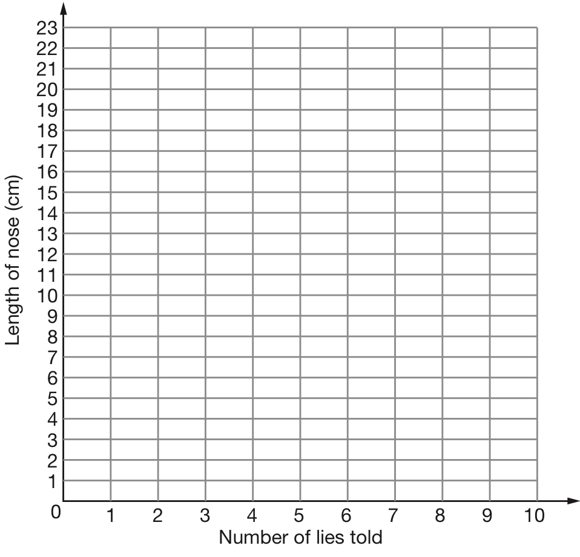 | 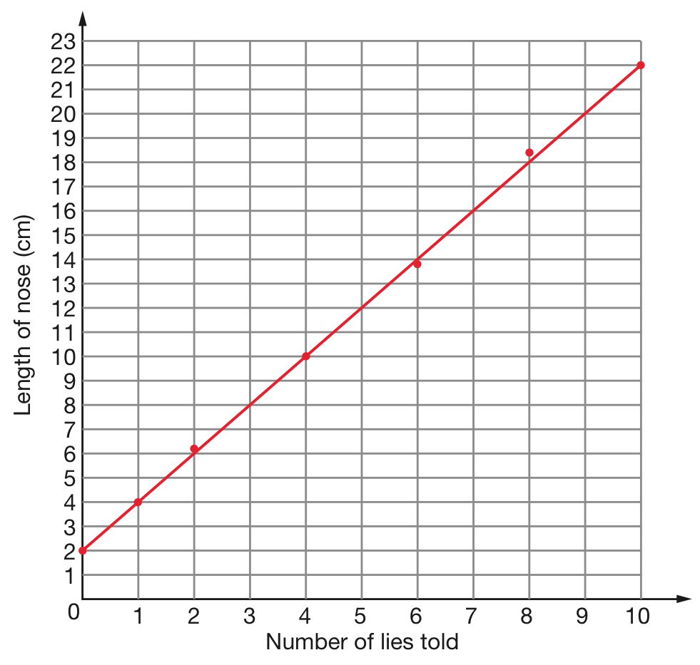
  Number of lies told | Length of nose (cm)
  0 | 2.0
  1 | 4.0
  2 | 6.2
  4 | 10.0
  6 | 13.8
  8 | 18.4
  10 | 22.0
 | a Look at the graph of the previous question and describe any trend that you can see.  b State how long Pinnochio’s nose was ‘naturally’, before any lies were told.  c Use the graph to predict the length of Pinnochio’s nose when he had told three lies.  d Predict how many lies needed to be told to produce a nose of length  20.0 cm. | a The length of nose constantly increased with every lie Pinnochio told.  b 2.0 cm.  c About 8.0 cm.  d About 9 lies. | 4
 | Didier thinks that fertiliser makes plants grow faster. He plants 50 identical seeds in two identical garden beds which are exposed to the same amount of sunlight. He gives both beds the same amount of water and adds fertiliser to one bed only.  a Propose a hypothesis for Didier’s experiment.  b Identify the variable being tested.  c List three controlled variables. | a I think that fertiliser makes plants grow faster.  b The presence/lack of fertiliser is being tested.  c Garden beds, amount of water and sunlight are controlled. | 5
 | Sasha wanted to test how fizzy different brands of orange soft drink were. She set up a test-tube rack and collected four test-tubes. Due to a shortage of equipment, she decided to use three medium-sized test-tubes and one large test-tube. She half-filled the large test tube with a soft drink (D) and timed how long it took for the drink to stop releasing bubbles. She then tested soft drinks A, B and C using the medium test tubes. Her results are shown in the table below. Sasha concluded that soft drink D was the brand that was the fizziest.  a Sasha did not run a fair test. Explain why.  b Discuss whether her conclusion can be trusted.  c Describe ways in which she could improve her method so that her results would be more reliable. | a A fair test only changes one variable at a time. In this case the variable being changed was the brand of orange drink. However, Sasha also changed the size of the test tube. Hence it is uncertain whether the difference in results is due to the different brands or the different test tubes.  b Soft drink D took longest to stop fizzing. This may have been because of the brand, but could also have been due to the larger test tube (hence more volume and surface area). Therefore her conclusion cannot be trusted. Soft drinks A, B and C were all in the same size test tubes so she can make a claim that brand B was the fizziest of those three.  c She needs to ensure all test tubes are the same size. | 6
  Soft drink | Time for fizzing to stop (s)
  A | 25
  B | 47
  C | 32
  D | 73

Section C— Thinking scientifically (10 marks)

 | The beam balance below has used a 100 g mass, a 10 g mass a 1 g mass and a 0.1 g mass to balance the weight of an object placed on it. What is the mass of the object?  A 1792 g  B 179.2 g  C 170.92 g  D 10070092 g  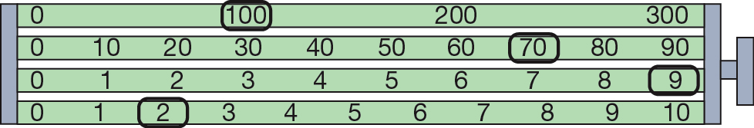 | b | 1
 | Five per cent of people have blood group type AB. This means that 5 out of every 100 people are AB. In a sample of 500 people, how many can be expected to have the blood group AB?  A 5  B 25  C 100  D 250 | b | 1
 | The label on a batch of matchboxes says ‘average contents 50’. This means that:  A each matchbox contains exactly 50 matches.  B the matches burn for 50 seconds on average.  C the matchboxes contain about 50 matches.  D the matches are 50 mm long. | c | 1
 | There are 1000 mm in 1 m and there are 1000 m in 1 km. How many millimetres are there in 1 km?  A 1000  B 10 000  C 100 000  D 1 000 000 | d | 1
 | The graph below shows information on one effect of smoking on health.  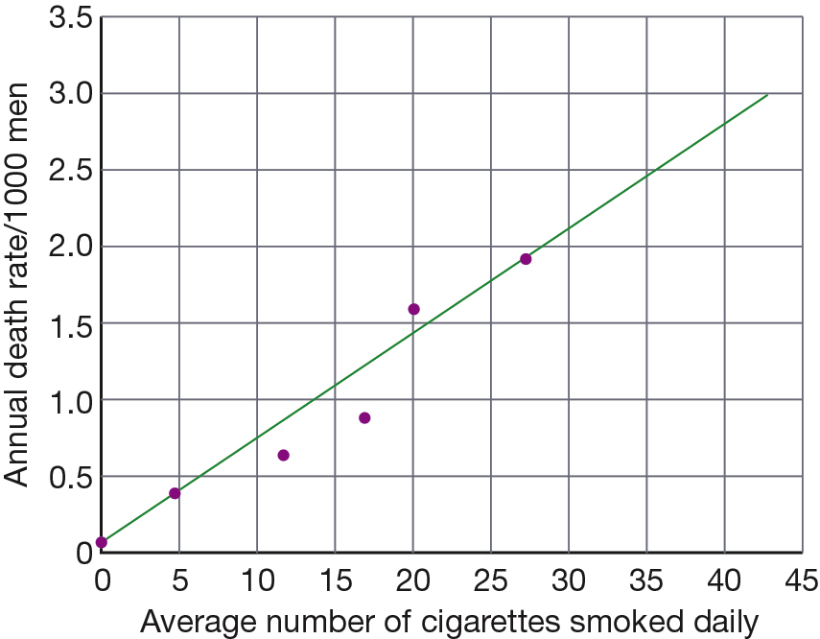  One thousand men smoke 20 cigarettes per day. Use the graph to determine how many are likely to die from lung cancer in one year.  A 1.5  B 2  C 20  D 1000 | a | 1
 | Six thousand men smoked 5 cigarettes per day. Use the graph in the previous question to determine how many are likely to die of lung cancer in one year.  A 0.5  B 5  C 3  D 6000 | c | 1
 | Which of the following statements best describes the link between the number of cigarettes smoked per day and deaths?  A The number of cigarettes smoked does not affect the number of men dying per year from lung cancer.  B The more cigarettes smoked daily, the more men die from lung cancer per year.  C The data obtained in this experiment cannot be trusted because sometimes it predicts that half a man might die.  D Smoking improves your health. | b | 1
 | The friction of four different surfaces was measured by pulling a block of wood across the surface of each tile with a spring balance. The following results were obtained.  Which type of tile had the greatest friction?  A polished wood  B carpet  C polished tile  D stone | b | 1
  Surface | Average force needed to move the block (N)
  polished wood | 9
  carpet | 21
  polished tile | 4
  stone | 15
 | Compare the friction of the carpet with the polished tile. Which of the following best compares the two surfaces?  A The friction of the polished tile is ¼ the friction of the carpet.  B The friction of the polished tile is ½ the friction of the carpet.  C The friction of the carpet is 4 times the friction of the polished tile.  D The friction of the carpet is 5 times the friction of the polished tile. | d | 1
 | Friction is required to get moving and to give you the grip needed to stop and change directions. Without it, you slip. Which surface would be the most slippery?  A polished wood  B carpet  C polished tile  D stone | c | 1

